The King’s Guard
Game Design Document

Student Name: Marcel Piotrowski
P-number:2714923
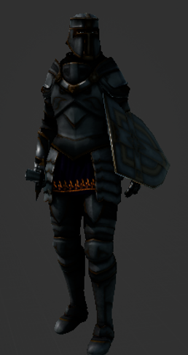

f

Contents
Game Concept Game Mechanics

Introduction | P3 | Core Game Play Mechanics | P4/5
Description | P3 | Player Character | P6
Key Features | P3/4 | Enemies | P7/8
Genre | P4 | Artificial Intelligence | P8
Platform | P4
Concept Art | P4 | Melee/Ranged | P8
 |  | Player Controls | P9

Interface Story & Level

HUD | P9 | Story | P11
Main Menu | P10 | Level | P11
Defeat Screen | P10

Sound And Music Art
Sound SFX | P10 | Art | P11
Soundtrack | P10

Game Concepts

Introduction
The King’s Guard is 2.5D side scroller experience for the pc. The protagonist is an unnamed knight who swore an oath to protect the King. The unnamed protagonist bound by a sacred oath to the elite “King's Guard” an elite squad of warriors tasked to protect the king. The protagonist will undergo a dangerous journey to save the King from an unknown threat.
Description
The unnamed knight has been tasked by his superiors to go save the king from the unknown threat's clutches. The player will need to traverse throughout levels to save the king. There will be enemies that the player will need to slay in order to save the king and traps to avoid.

Key Features

Sword Combat:
Player will have the ability to engage the enemy with melee combat with the use of his sword.
Spell Casting :
The knight blessed nature allows him to cast spells that can harm enemies from afar.
Consumables:
The player throughout the game will be able to collect potions to stock up on. Those potions will either regen his health or mana. There will be a finite amount of these potions so the player will need to be careful with his engagements with the enemy as he may run out.

Sound:
The game will contain a soundtrack throughout the menus and level. Melee combat and spell casting will both have SFX attached to them. Same with the usage of consumables.

Genre
The King’s Guard will be a mix of a few genres. As it is an Action, strategy and shooter game (spell casting). With the main focus on action and shooter.

Platform
The targeted platform for this game is PC.

Concept Art
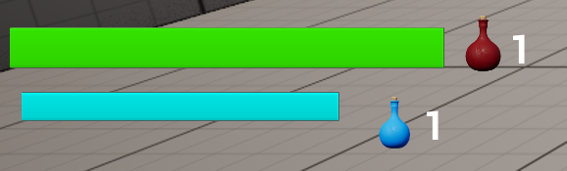

Game Mechanics

Core Game Play Mechanics
The core gameplay behind The King’s Guard will be fighting monsters while trying to maintain your health and mana levels.

Movement
Player movement will play a huge part on maintaining your player health as spacing the enemy will lower the overall damage you take. The player movement consists of standard WASD movement with the addition of jumping on space bar, the player has the ability to double jump which allows him to either jump over the enemies and evade them or try to get a height advantage over them.
Combat
The combat will be split between Melee and Ranged combat.
Melee combat consists of the player swinging his sword, upon contact with the enemy the enemy would take damage to his health, once it reaches 0 the enemy will die. The player needs to watch out as enemies are able to do high amount of melee damage back to the player.
Ranged Combat consists of spell casting from the player. Ranged combat is harder to execute as you have to shoot where your player character is facing towards and not the camera direction. This may cause players to miss their shots. For the player to be able to cast his spells they will require mana. The only way for the player to gain mana is through mana potions.
Consumables
Consumables are split between health and mana potions. Upon reaching a consumable the player can interact with it to take it and use to restore mana or health depending on the key used. Consumables don't respawn throughout the level so the player needs to carefully manage his health and mana.

Traps
Throughout the game there will be environmental traps that the player must look out for. As they will damage the player upon contact. The traps may range from stationary spikes or projectiles shooting that the player needs to dodge.

Player Character
“Unnamed Knight”


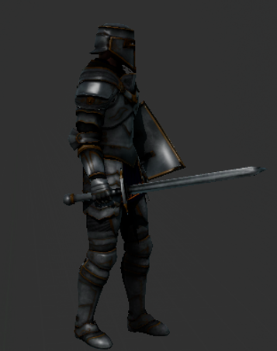

Unnamed Knight is the player character of the game. The knight was on a mission ordered by the king to slaughter some bandits near Gdonsk the holy capital. On his way back from the mission a squire came to him and informed him of the Kings capture by the unknown forces. The Knight now needs to traverse back to the capital to rescue the king under all means necessary.

Enemies

Plagued

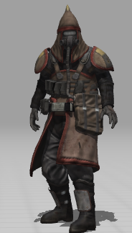
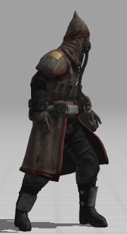

The Plagued are unnamed warriors who wear gas masks to hide their disfigured faces from the backlash from the use of dark magic that backfired on them. The Plagued are the melee troops under the control of the demons. They are the weakest troops coming from the unknown's army.
Health | 100 | Melee
Attack | 10
Demon Mage
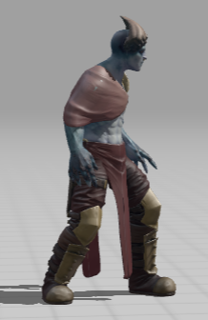
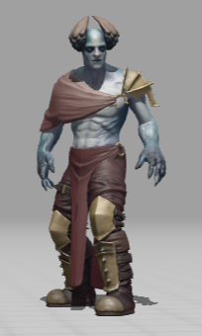

Demon Mages are the overseers of the plagued they bind the plagued under a dark contract that makes them yield their control to their masters. The demonic mages are one tier above the plagued and are the ranged troops of the unknowns army . They posses the ability to cast fireballs that deal extreme damage to the player.
Health | 150 | Ranged
Attack | 25
Artificial Intelligence
The enemies in the game will react on the sense of sight. The Ai will original make the enemies roam in their designated area however the moment they spawn the player they will go and chase the player and attack until they lose sight again. If the player manages to sneak upon the enemy and deal damage to it, the enemy will again react to the stimuli and turn around from where the damage came from and chase the player. If it loses sight, it will go back to roam its specific area.
Between the plagued and demon mages they will react different to the player. The plagued upon seeing the player will engage in melee combat while the demonic mages will shoot from afar.

Melee/Ranged
Melee (Sword) | Attack | 20
Ranged (Spell) | Attack | 40
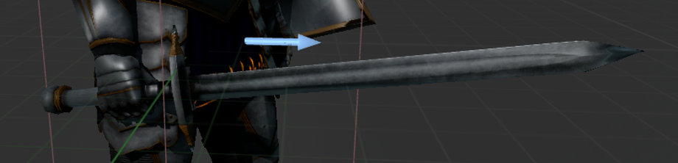
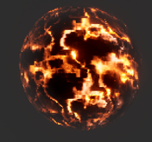

Player Controls
Left Mouse Button -> Melee
Right Mouse Button -> Cast Spell
WASD -> Movement
C -> interact with potions
V -> use mana potion
X -> use health potion
Space Bar -> jump
Interface
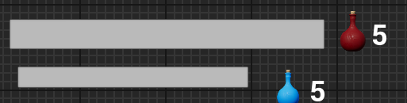

Player is able to see his health and mana in a bar and how many potions he has.
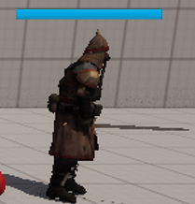
Enemies have health bars to show how much
health they have left.

Start Menu
Will consist of two buttons one to start the game and the other to close the application down.
Defeat Screen
Once the Player dies in the game he will be presented with a defeat screen which will allow him to either go back to start menu or exit from application.

Sound
Sound SFX
The players actions will cause sound, such as swinging a sword, casting a spell and dying.
Soundtrack
The entire game will have a sound track playing.
Story & Level
Story

200 Years Ago, the demon king invaded Gdonsk and its neighbouring countries, it led to the human population decreasing by 95%. The humans were losing hard against the demon hordes until the revelation from the gods. Which bestowed some humans with special powers, one of them being the ability to control mana in the air. A group of these special humans grouped up and defeated the demon king and brought peace to Gdonsk. After the long peace trouble started brewing an unknown organisation contracted demons from hell and took over Gdonsk. All of humanity have lost their powers through the passage of time as the era was peaceful and there was no need for anyone to train their magic skills anymore . On the day the unnamed knight was given his role as the kings guard , the goddess sent her powers to the knight. The powers gave the knight the long lost art of feeling mana and casting spells .She then tasked the knight to prepare himself for the future. After his rise in rank and new magic power harnessed the knight trained himself in using the power. As he was new to controlling mana all the knight could do for now was cast a fire ball. Few weeks later the knight was tasked with exterminating bandits from a nearby village. Little did he know that would be the last time he would see Gdonsk in all his glory and not chaos from the unknown attack, which took the lives of many. Throughout the battle in Gdonsk the king was captured by the enemies , however before his capture he sent a squire to inform the knight of the fall of Gdonsk and tasking him with the elimination of the evil and saving of the country.
Level
The player will be traversing through a forest and abandoned town. On his way to the capital, he will encounter enemies and traps on his way there. He will need to defeat them to carry on.


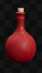
Art



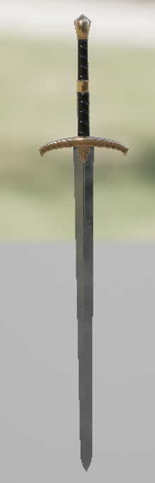



Technical Design Document
Player Movement
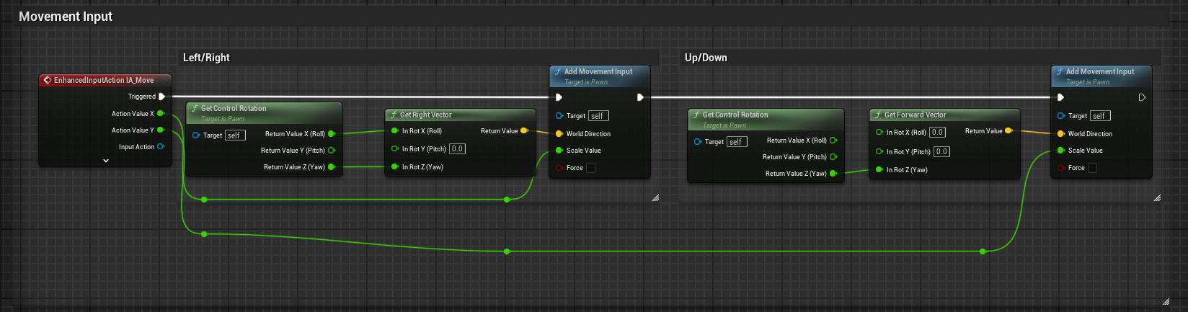

Player movement is handled through blueprints. Enhanced input system is being utilised. The specific enhancedInputAction being used is IA_Move.
Here you can see that IA_Move has 4 keys assigned to it W A S D which determine the players X value and Y value. These direction vectors are derived from controlRotations Yaw. Here you can further see mappings for the jumping, attack and the ranged attack.

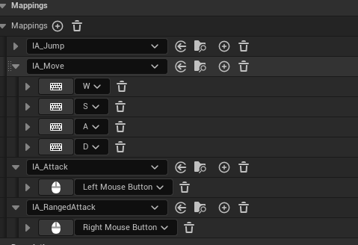

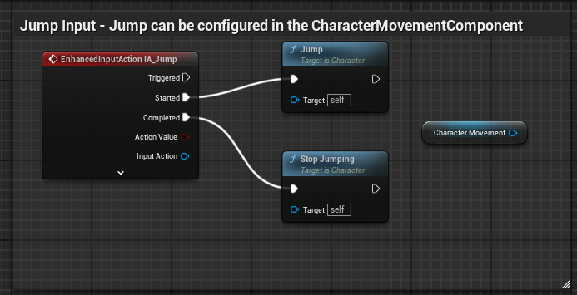

Here is the Blueprint nodes for the jumping the logic is derived from the character movement component. Through the character movement component I could control the height of jumping , the effect gravity has and how many times the player can jump which was changed to 2 times. Which is double jump.

Player Attack
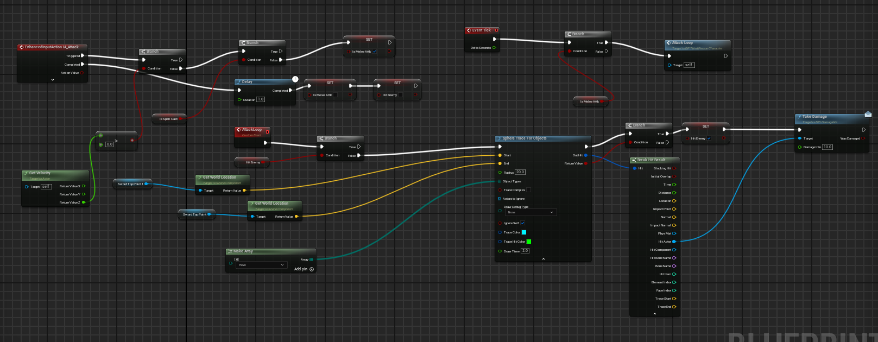

The player attack input is quite lengthy. First i will start off on the enhanced input action itself. First there is a check to see the players Z value to see if he is jumping or not. If the player isn't jumping its checking if he is currently casting a spell if its false, then the player will isMeleeAttack variable to true. Which runs an animation for melee.
On event tick the player will run the attack loop custom event only when the variable melee attack is set to true.
The custom event AttackLoop first starts of with a branch to see if the player has hit the enemy, if false it runs a sphere trace. The sphere traces position is based on two points on the sword and the object type it should hit is only pawn. Once you get a successful pawn hit . It sets hit enemy to true which stops the loop, preventing the player from hitting the enemy multiple times with one hit. Then it goes and deals 10 damage to the pawn it hit. The take damage function comes from an interface which only allows the damage to take place if they have BPC_DamageSystem component.
Player Ranged Attack
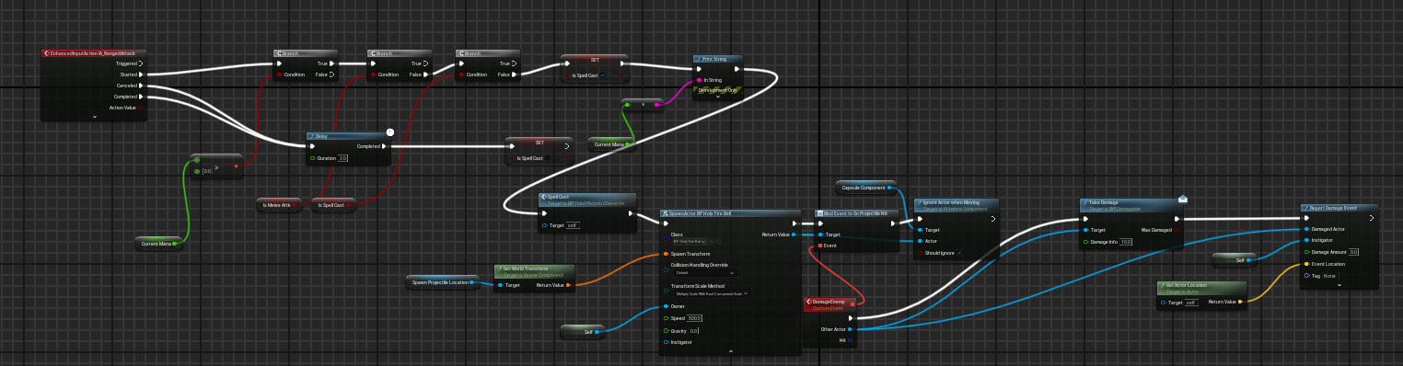

On press of right mouse button there are 3 different branches . 1st on checks if the player has enough mana to cast the spell , 2nd checks if he is melee attacking and the 3rd one checks if its already casting a spell. This is used so the player cant spam the button and shoot 2 bullets at once.
It sets spell cast function to true , prints current mana for debugging purposes then runs the spell cost function to remove mana from the player.
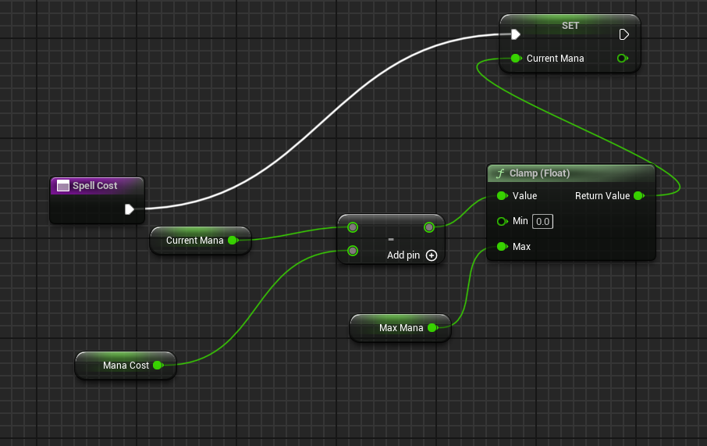
It then spawns my fireball actor at spawn projectile
location which is just a scene component to get the
position in world space from. Then it binds
Damage enemy custom event on to projectile hit.

It then ignores the actor when moving so the player cant hit himself if he is faster than the projectile.Then it runs take damage on the other actor it hits. Then there is Report Damage Event which is used to alert the ai of the players position when it gets hit by the fireball.
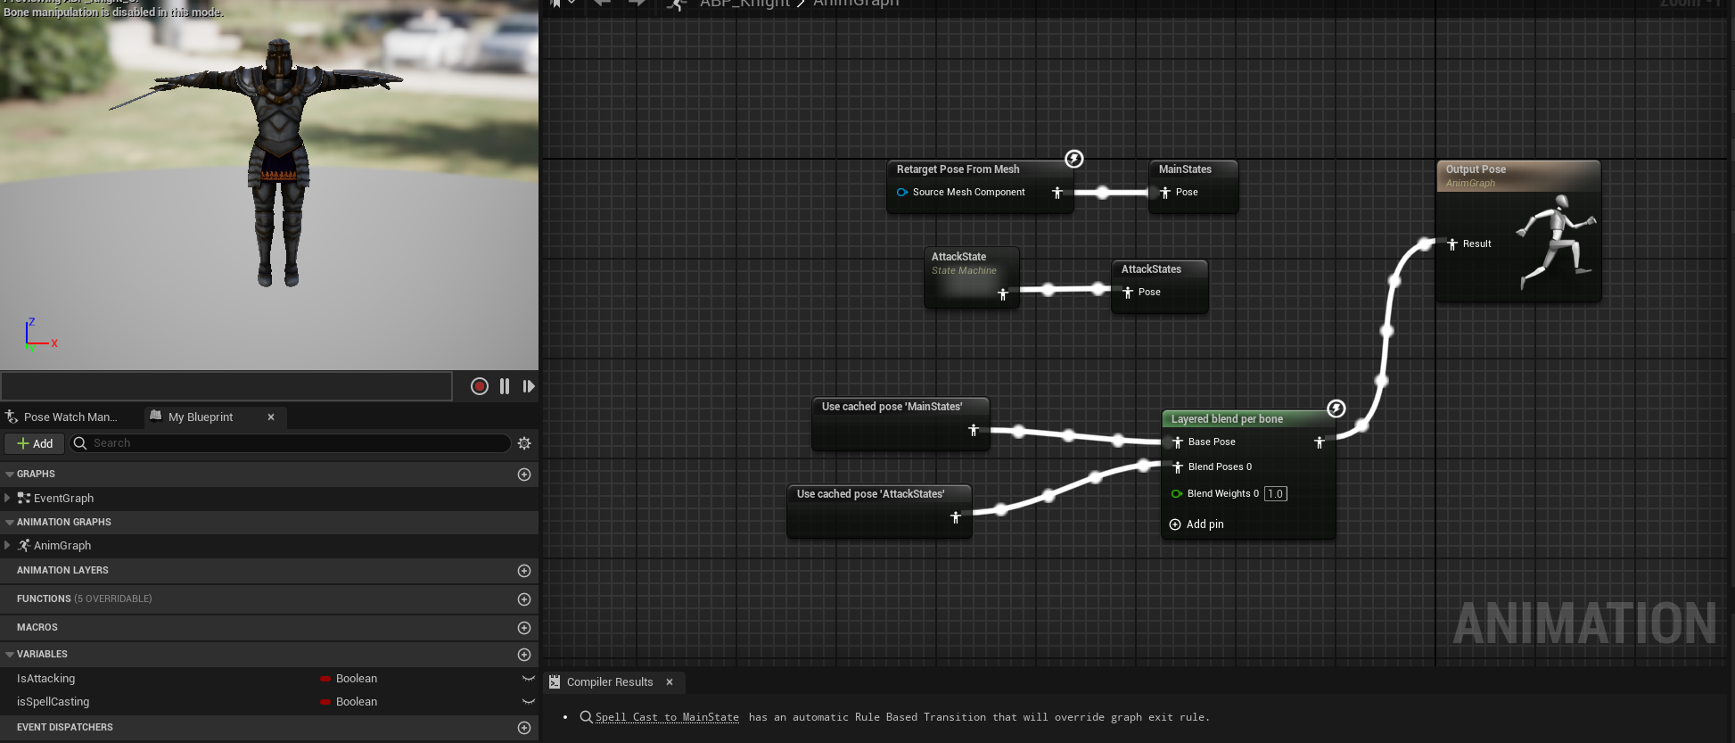
Player Animation

Players animation are retargeted from ABP_Manny with the exception of mele attack and ranged attack.It utilizes the state machine to switch from main states to attack state and spell cast.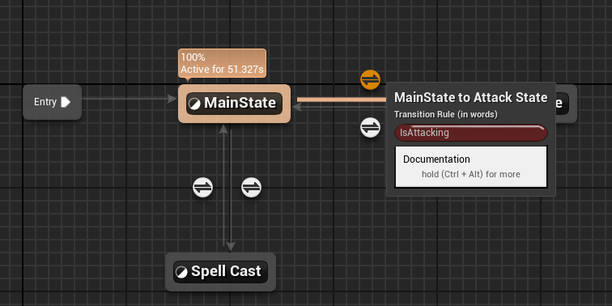
The same condition is needing for spell cast but the variable is isSpellCasting and it sets it to true.
Further down there is a blend from two poses the main state and attack state and it's separated on the spine bone. So, when the player runs, he can attack and only the top part of the animation will attack.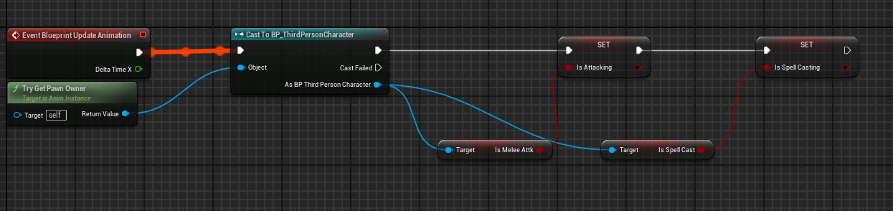
This just syncs the animations variables to the players variables.

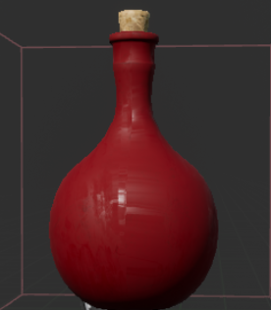
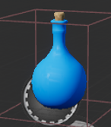
Collectables(Potions)

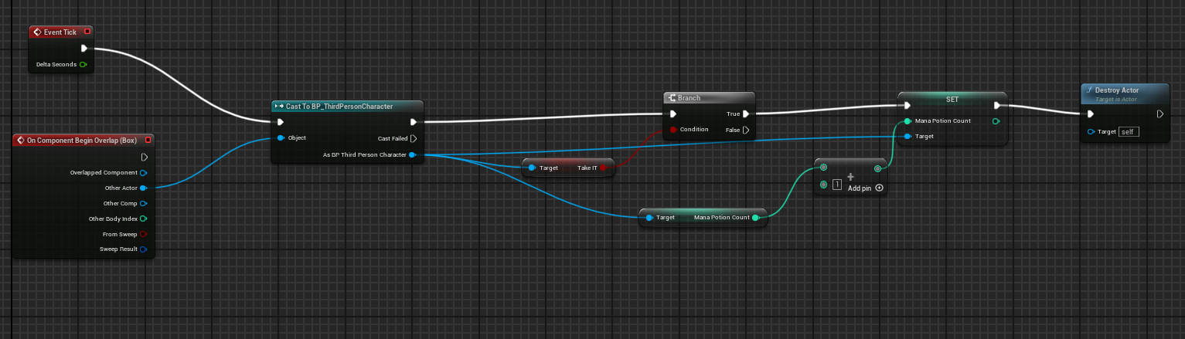

If the player overlaps with the mana potion and take IT is true the player sets mana potion count +1 and then destroys the actor in the world. The same logic is used for the health potion.
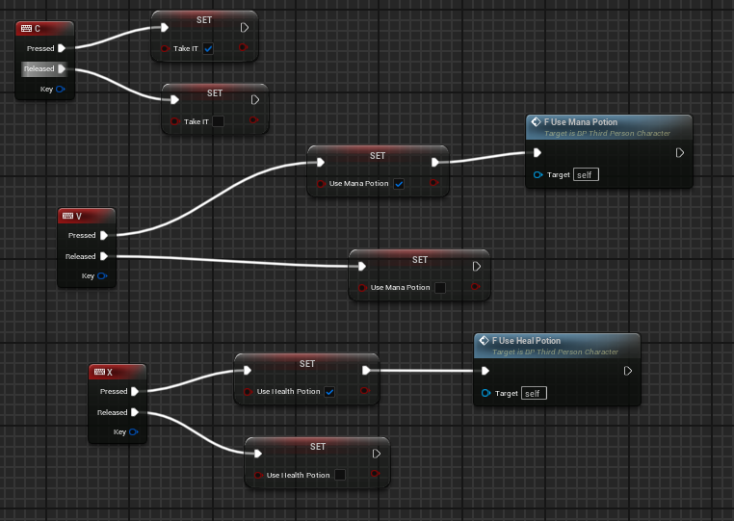
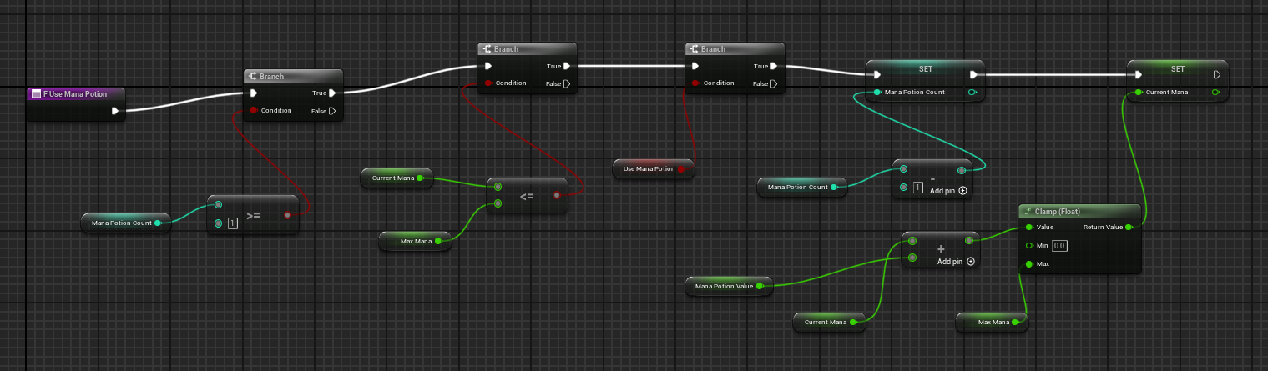This function is in the player character and it has 3 branches . The 1st one checks for the mana potion count and if its greater or equal than 1 if true it goes to the 2nd branch and checks if current mana is less than max mana if true it goes to the last branch. Which checks if useManaPotion is set to true. If it is it decreases the potion count from variable and adds mana to the player while maintaining its max amount from overflowing. It's practically the same for the Health Potion.

Player UI
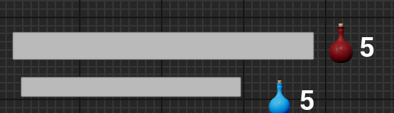
The player UI consists of two progress bars which fill based on 2 functions Get_HealthBar_Percent and the same for mana. It also has two texts which change on how many potions you have of the respective kind.
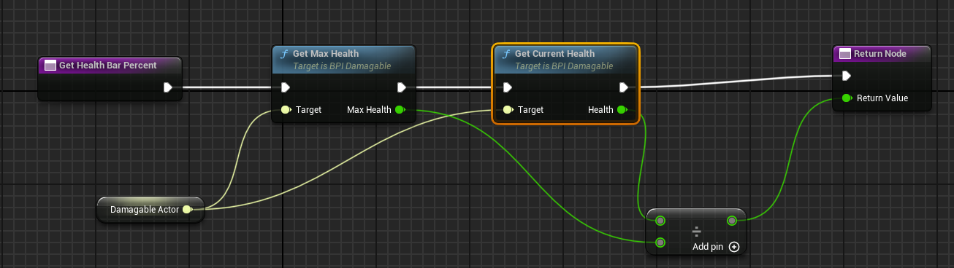
Checks the Max Health of the player and its current Health divides both by each other and returns the result. So if player has 100 max health and has 100 health it would return 1 which fills the bar.
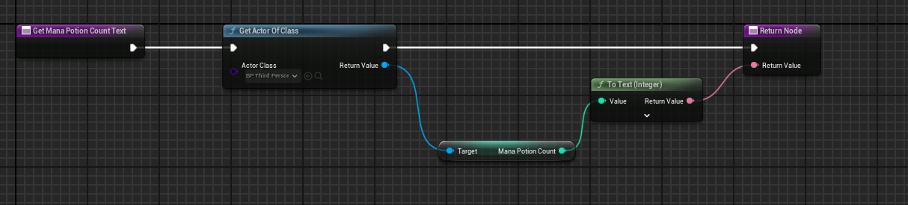
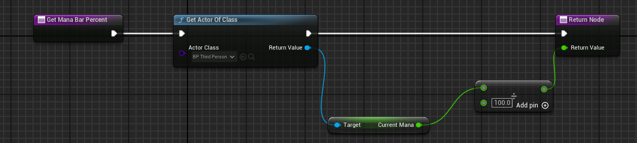Gets the players class and gets the player mana divides the value by 100 and returns the result. For the Potion its the same besides dividing by 100.

Enemy AI
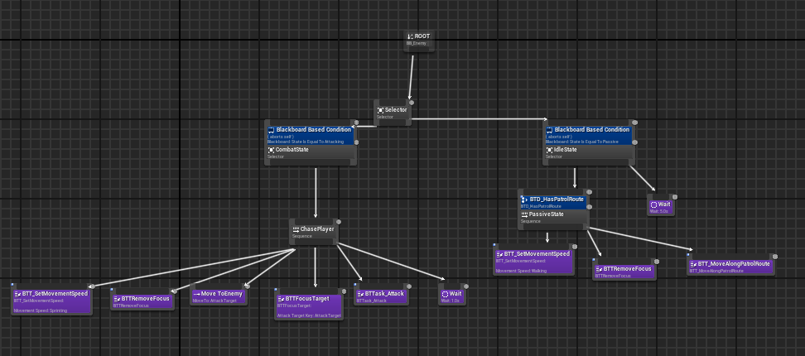
Enemy Ai is handled through a behaviour tree.
First you start of with a selector between Combat State and Idle State.
They both have a decorator which runs the tree if its condition is met.
For the Combat state it requires the enemies state to be attacking while for the idleState it requires the enemy to be in passive state.
Ai has an Enum of states ranging from dead , idle and attacking. The state changes on perception and if it got damaged by the player.
Here is the function that changes the state to attacking from passive.
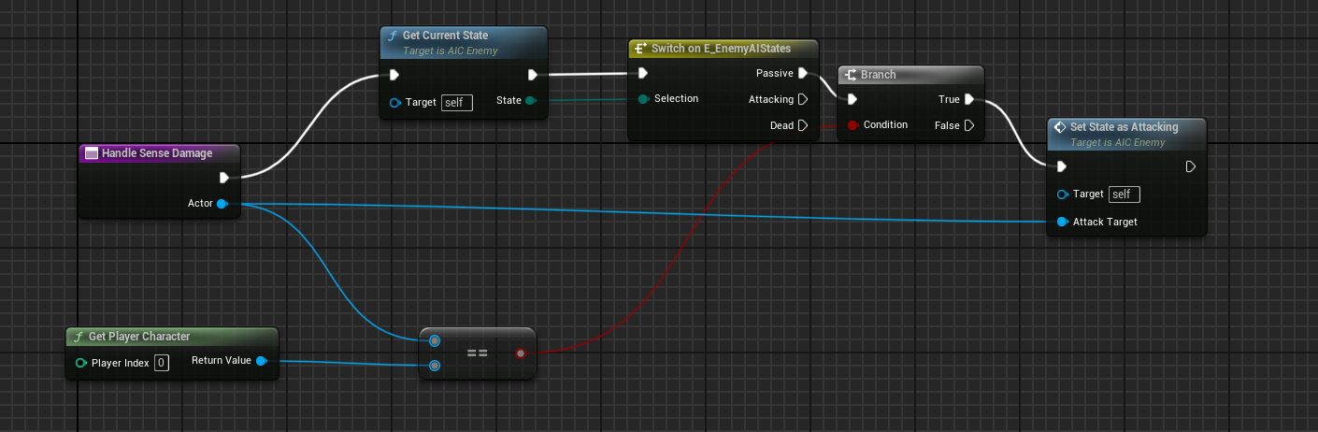

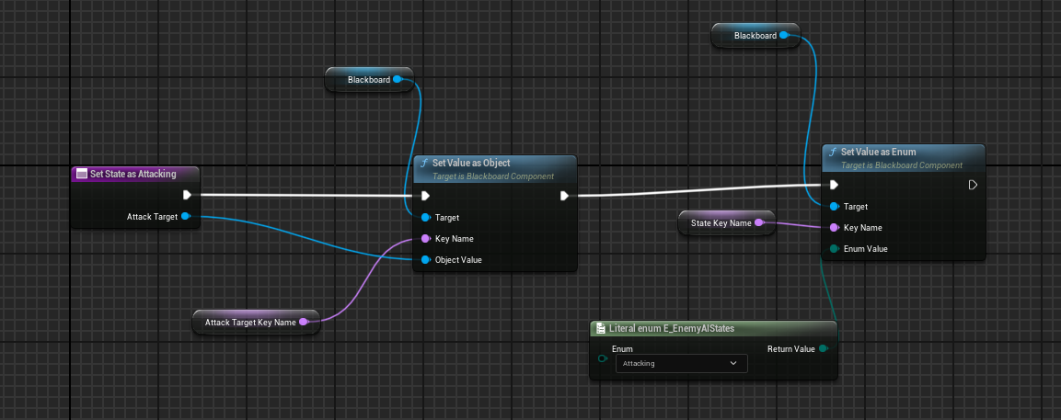

The same is done for passive, the only difference is that the Enum is set to passive instead of attacking. The left tree has a sequence which starts of changing the enemies movement speed then it removes the focus from the player so the enemy. Removing focus stops the enemy facing towards the player, which without it would face the player while he roamed and not towards where he should look . Then the move to enemy makes the ai walk Infront of the attackTarget(player). BTTFocusTarget makes the enemy face the player then it runs BTTask_Attack which attacks the player.
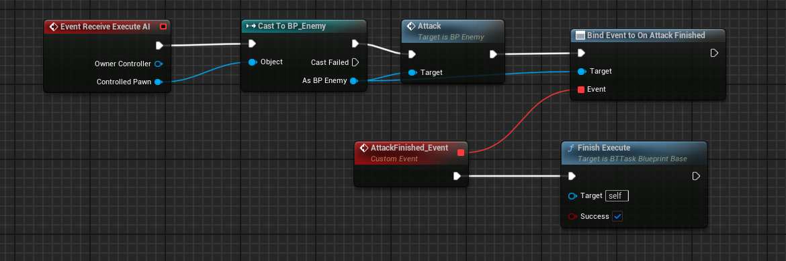
Now moving on to the right side of the behaviour tree it checks if the enemy state is passive if it is it checks if the ai has a patrol route. If it does it changes the movement speed to walking removes the focus target from player to state and then makes the ai move along the patrol route.
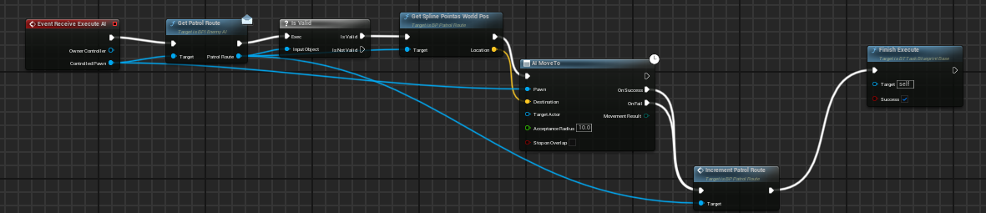
Gets the patrol route set to the enemy checks if its valid if it is runs spline point as world pos function which then takes the location in world position and gives it to AI move to. It then increments Patrol route by 1 and finishes the task.
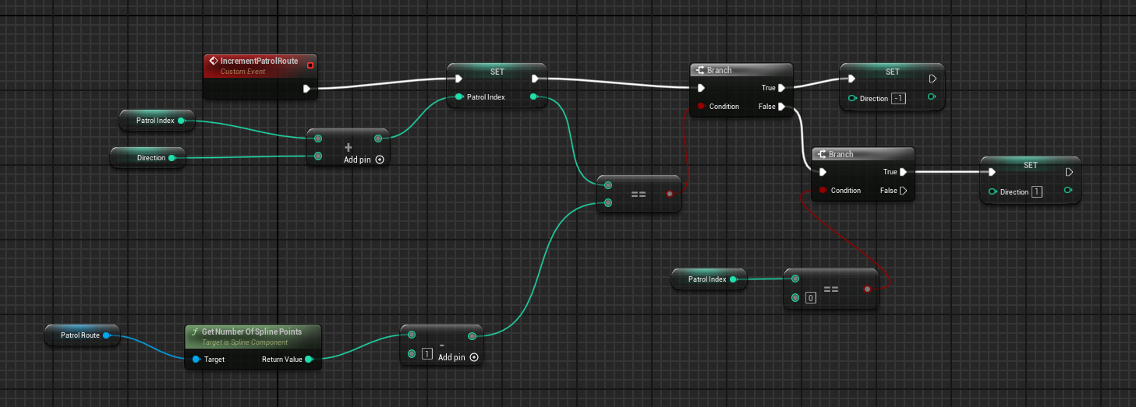

Enemy UI

Enemies in the game have a widget component attached to their mesh.
The widget component attached is WB_EnemyHealthBar. The widget
Size has been assigned to 200 by 20.
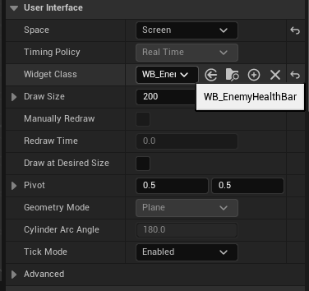

The WB_EnemyHealthBar is a canvas panel with a progress bar inside of it.The progress bar percent is filled by Get_HealthBar_Percent. Which is the exact same for the player. It gets the owners current health and divides it by its max health and returns that value.
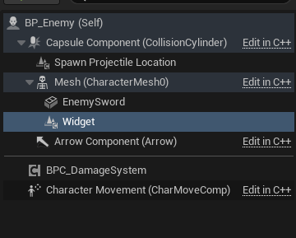

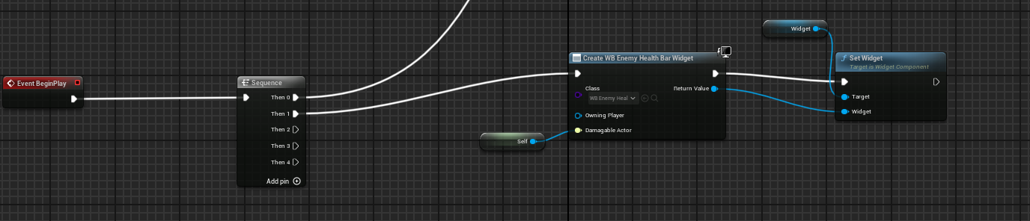
On Event BeginPlay the enemy creates a widget of class WB_EnemyHealthBar and the sets the widget to the screen using the widget reference.

Player And Enemy Death handling

Enemy Death handling
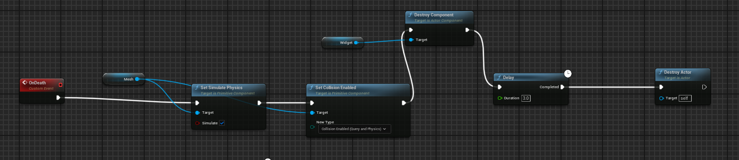
BP_Enemy has a custom Event OnDeath which is triggered once the enemy's health variable falls to 0. The custom event makes the enemies mesh simulate physics and change its collision type to query and physics. It then destroys the enemy's widget from the screen and after a 3 second delay it will destroy the actor. The delay is set there so the body of the enemy would not disappear straight away upon death
Player Death handling
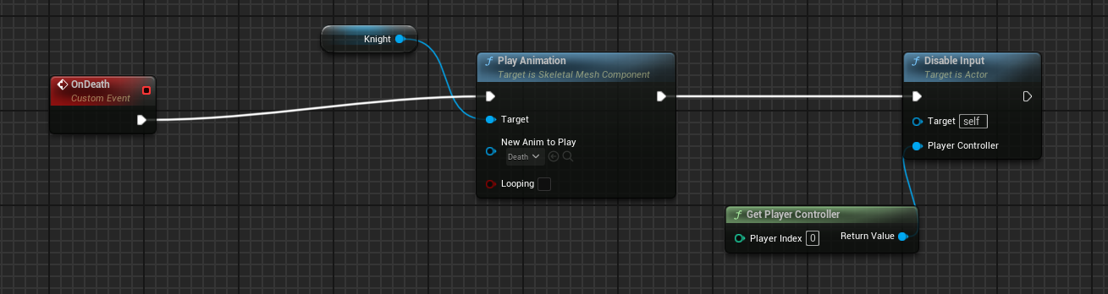
For the player the death handling is a lot simpler, it will run when the player has 0 health, the same way the enemy does. But instead of changing the physics of the mesh, the player will play his death animation and immediately after it will disable any input from happening while the player is dead. As we do not want the player to be able to move or attack while dead.

For both the player and enemy at the end of both nodes is where i would add sound sfx for death later on.

